Lab – Subnetting Network Topologies (Instructor Version)

**Instructor Note**: Red font color or Gray highlights indicate text that appears in the instructor copy only.

1. Objectives

Parts 1 to 5, for each network topology:

* Determine the number of subnets.
* Design an appropriate addressing scheme.
* Assign addresses and subnet mask pairs to device interfaces.
* Examine the use of the available network address space and future growth potential.

1. Background / Scenario

When given a network topology, it is important to be able to determine the number of subnets required. In this lab, several scenario topologies will be provided, along with a base network address and mask. You will subnet the network address and provide an IP addressing scheme that will accommodate the number of subnets displayed in the topology diagram. You must determine the number of bits to borrow, the number of hosts per subnet, and potential for growth as specified by the instructions.

1. Network Topology A

In Part 1, you have been given the 192.168.10.0/24 network address to subnet, with the following topology. Determine the number of networks needed and then design an appropriate addressing scheme.

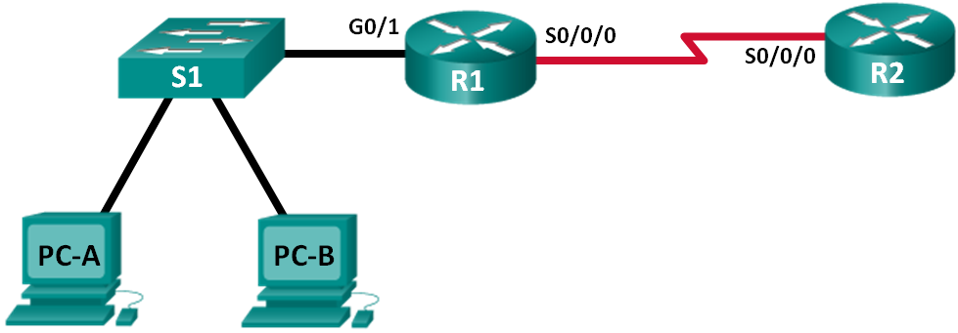

* 1. Determine the number of subnets in Network Topology A.
     1. How many subnets are there? ___________ 2
     2. How many bits should you borrow to create the required number of subnets? _________ 1
     3. How many usable host addresses per subnet are in this addressing scheme? ___________ 126
     4. What is the new subnet mask in dotted decimal format? _________________________ 255.255.255.128
     5. How many subnets are available for future use? _______________ 0
  2. Record the subnet information.

Fill in the following table with the subnet information:

|  |  |  |  |  |
| --- | --- | --- | --- | --- |
| Subnet Number | Subnet Address | First Usable Host Address | Last Usable Host Address | Broadcast Address |
| 0 | 192.168.10.0 | 192.168.10.1 | 192.168.10.126 | 192.168.10.127 |
| 1 | 192.168.10.128 | 192.168.10.129 | 192.168.10.254 | 192.168.10.255 |
| 2 |  |  |  |  |
| 3 |  |  |  |  |
| 4 |  |  |  |  |
| 5 |  |  |  |  |

1. Network Topology B

The network topology from Part 1 has expanded to accommodate the addition of router R3 and its accompanying network, as illustrated in the following topology. Use the 192.168.10.0/24 network address to provide addresses to the network devices, and then design a new addressing scheme to support the additional network requirement.

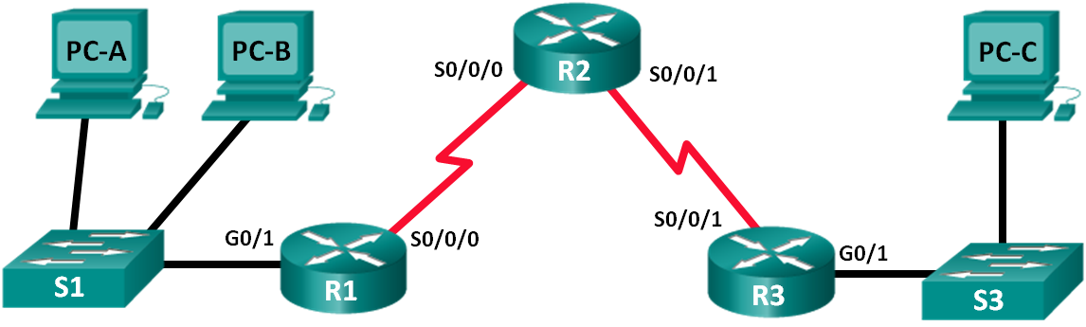

* 1. Determine the number of subnets in Network Topology B.
     1. How many subnets are there? ___________ 4
     2. How many bits should you borrow to create the required number of subnets? _________ 2
     3. How many usable host addresses per subnet are in this addressing scheme? ___________ 62
     4. What is the new subnet mask in dotted decimal format? _________________________ 255.255.255.192
     5. How many subnets are available for future use? _______________ 0
  2. Record the subnet information.

Fill in the following table with the subnet information:

|  |  |  |  |  |
| --- | --- | --- | --- | --- |
| Subnet Number | Subnet Address | First Usable Host Address | Last Usable Host Address | Broadcast Address |
| 0 | 192.168.10.0 | 192.168.10.1 | 192.168.10.62 | 192.168.10.63 |
| 1 | 192.168.10.64 | 192.168.10.65 | 192.168.10.126 | 192.168.10.127 |
| 2 | 192.168.10.128 | 192.168.10.129 | 192.168.10.190 | 192.168.10.191 |
| 3 | 192.168.10.192 | 192.168.10.193 | 192.168.10.254 | 192.168.10.255 |
| 4 |  |  |  |  |
| 5 |  |  |  |  |
| 6 |  |  |  |  |
| 7 |  |  |  |  |

1. Network Topology C

The topology has changed again with a new LAN added to R2 and a redundant link between R1 and R3. Use the 192.168.10.0/24 network address to provide addresses to the network devices. Also provide an IP address scheme that will accommodate these additional devices. For this topology, assign a subnet to each network.

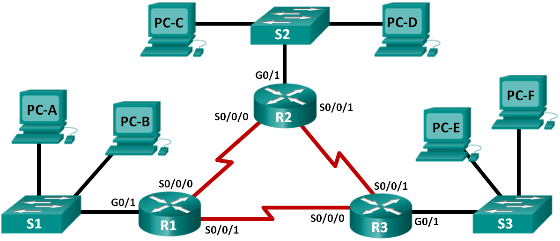

* 1. Determine the number of subnets in Network Topology C.
     1. How many subnets are there? ___________ 6
     2. How many bits should you borrow to create the required number of subnets? _________ 3
     3. How many usable host addresses per subnet are in this addressing scheme? ___________ 30
     4. What is the new subnet mask in dotted decimal format? _________________________ 255.255.255.224
     5. How many subnets are available for future use? _______________ 2
  2. Record the subnet information.

Fill in the following table with the subnet information:

|  |  |  |  |  |
| --- | --- | --- | --- | --- |
| Subnet Number | Subnet Address | First Usable Host Address | Last Usable Host Address | Broadcast Address |
| 0 | 192.168.10.0 | 192.168.10.1 | 192.168.10.30 | 192.168.10.31 |
| 1 | 192.168.10.32 | 192.168.10.33 | 192.168.10.62 | 192.168.10.63 |
| 2 | 192.168.10.64 | 192.168.10.65 | 192.168.10.94 | 192.168.10.95 |
| 3 | 192.168.10.96 | 192.168.10.97 | 192.168.10.126 | 192.168.10.127 |
| 4 | 192.168.10.128 | 192.168.10.129 | 192.168.10.158 | 192.168.10.159 |
| 5 | 192.168.10.160 | 192.168.10.161 | 192.168.10.190 | 192.168.10.191 |
| 6 | 192.168.10.192 | 192.168.10.193 | 192.168.10.222 | 192.168.10.223 |
| 7 | 192.168.10.224 | 192.168.10.225 | 192.168.10.254 | 192.168.10.255 |
| 8 |  |  |  |  |
| 9 |  |  |  |  |
| 10 |  |  |  |  |

* 1. Assign addresses to network devices in the subnets.
     1. Fill in the following table with IP addresses and subnet masks for the router interfaces:

**Instructor Note**: These are suggested IP addresses based on using the first 6 subnets from the table above as assigned to each segment.

|  |  |  |  |
| --- | --- | --- | --- |
| Device | Interface | IP Address | Subnet Mask |
| R1 | GigabitEthernet 0/1 | 192.168.10.1 | 255.255.255.224 |
|  | Serial 0/0/0 | 192.168.10.33 | 255.255.255.224 |
|  | Serial 0/0/1 | 192.168.10.65 | 255.255.255.224 |
| R2 | GigabitEthernet 0/1 | 192.168.10.97 | 255.255.255.224 |
|  | Serial 0/0/0 | 192.168.10.34 | 255.255.255.224 |
|  | Serial 0/0/1 | 192.168.10.129 | 255.255.255.224 |
| R3 | GigabitEthernet 0/1 | 192.168.10.161 | 255.255.255.224 |
|  | Serial 0/0/0 | 192.168.10.66 | 255.255.255.224 |
|  | Serial 0/0/1 | 192.168.10.130 | 255.255.255.224 |

* + 1. Fill in the following table with the IP addresses and subnet masks for devices in the LAN as displayed in topology.

**Instructor Note**: These are suggested IP addresses based on using the first 6 subnets from the table above as assigned to each segment.

|  |  |  |  |  |
| --- | --- | --- | --- | --- |
| Device | Interface | IP Address | Subnet Mask | Default Gateway |
| PC-A | NIC | 192.168.10.30 | 255.255.255.224 | 192.168.10.1 |
| PC-B | NIC | 192.168.10.29 | 255.255.255.224 | 192.168.10.1 |
| S1 | VLAN 1 | 192.168.10.2 | 255.255.255.224 | 192.168.10.1 |
| PC-C | NIC | 192.168.10.126 | 255.255.255.224 | 192.168.10.97 |
| PC-D | NIC | 192.168.10.125 | 255.255.255.224 | 192.168.10.97 |
| S2 | VLAN 1 | 192.168.10.98 | 255.255.255.224 | 192.168.10.97 |
| PC-E | NIC | 192.168.10.190 | 255.255.255.224 | 192.168.10.161 |
| PC-F | NIC | 192.168.10.189 | 255.255.255.224 | 192.168.10.161 |
| S3 | VLAN 1 | 192.168.10.162 | 255.255.255.224 | 192.168.10.161 |

1. Network Topology D

The network was modified to accommodate changes in the organization. The 192.168.10.0/24 network address is used to provide the addresses in the network.

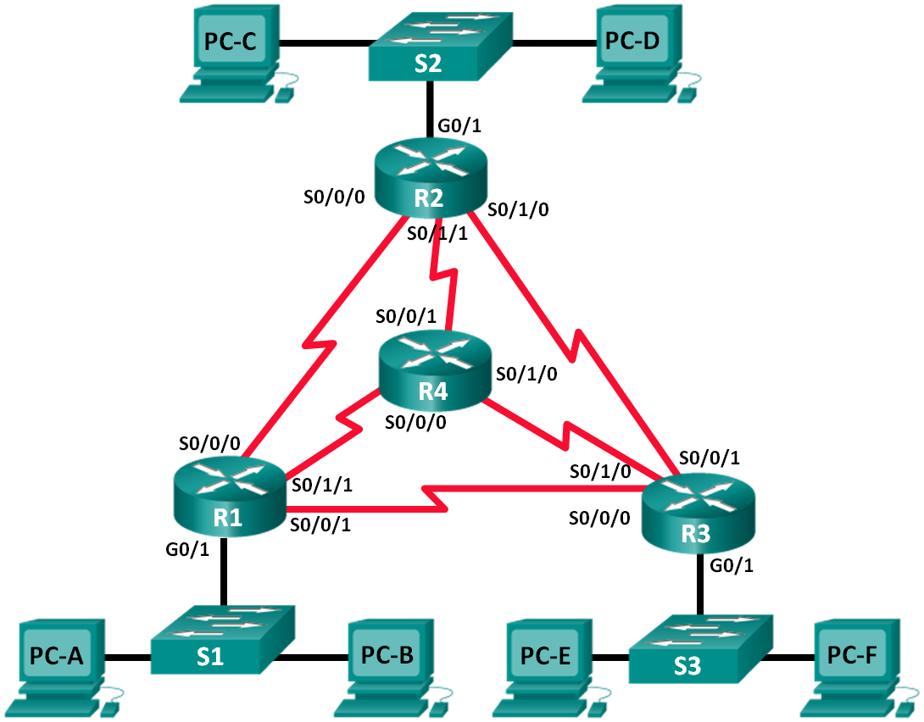

* 1. Determine the number of subnets in Network Topology D.
     1. How many subnets are there? ___________ 9
     2. How many bits should you borrow to create the required number of subnets? _________ 4
     3. How many usable host addresses per subnet are in this addressing scheme? ___________ 14
     4. What is the new subnet mask in dotted decimal format? _________________________ 255.255.255.240
     5. How many subnets are available for future use? _______________ 7
  2. Record the subnet information.

Fill in the following table with the subnet information.

|  |  |  |  |  |
| --- | --- | --- | --- | --- |
| Subnet Number | Subnet Address | First Usable Host Address | Last Usable Host Address | Broadcast Address |
| 0 | 192.168.10.0 | 192.168.10.1 | 192.168.10.14 | 192.168.10.15 |
| 1 | 192.168.10.16 | 192.168.10.17 | 192.168.10.30 | 192.168.10.31 |
| 2 | 192.168.10.32 | 192.168.10.33 | 192.168.10.46 | 192.168.10.47 |
| 3 | 192.168.10.48 | 192.168.10.49 | 192.168.10.62 | 192.168.10.63 |
| 4 | 192.168.10.64 | 192.168.10.65 | 192.168.10.78 | 192.168.10.79 |
| 5 | 192.168.10.80 | 192.168.10.81 | 192.168.10.94 | 192.168.10.95 |
| 6 | 192.168.10.96 | 192.168.10.97 | 192.168.10.110 | 192.168.10.111 |
| 7 | 192.168.10.112 | 192.168.10.111 | 192.168.10.126 | 192.168.10.127 |
| 8 | 192.168.10.128 | 192.168.10.129 | 192.168.10.142 | 192.168.10.143 |
| 9 | 192.168.10.144 | 192.168.10.145 | 192.168.10.158 | 192.168.10.159 |
| 10 | 192.168.10.160 | 192.168.10.161 | 192.168.10.174 | 192.168.10.175 |
| 11 | 192.168.10.176 | 192.168.10.177 | 192.168.10.190 | 192.168.10.191 |
| 12 | 192.168.10.192 | 192.168.10.193 | 192.168.10.206 | 192.168.10.207 |
| 13 | 192.168.10.208 | 192.168.10.209 | 192.168.10.222 | 192.168.10.223 |
| 14 | 192.168.10.224 | 192.168.10.225 | 192.168.10.238 | 192.168.10.239 |
| 15 | 192.168.10.240 | 192.168.10.241 | 192.168.10.254 | 192.168.10.255 |
| 16 |  |  |  |  |
| 17 |  |  |  |  |

1. Network Topology E

The organization has a network address of 172.16.128.0/17 to be divided as illustrated in the following topology. You must choose an addressing scheme that can accommodate the number of networks and hosts in the topology.

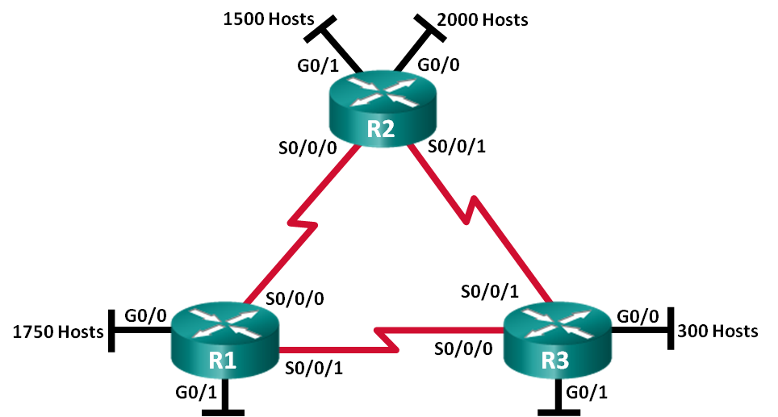

* 1. Determine the number of subnets in Network Topology E.
     1. How many subnets are there? ___________ 9
     2. How many bits should you borrow to create the required number of subnets? _________ 4
     3. How many usable host addresses per subnet are in this addressing scheme? ___________ 2046
     4. What is the new subnet mask in dotted decimal format? _________________________ 255.255.248.0
     5. How many subnets are available for future use? _______________ 7
  2. Record the subnet information.

Fill in the following table with the subnet information:

|  |  |  |  |  |
| --- | --- | --- | --- | --- |
| Subnet Number | Subnet Address | First Usable Host Address | Last Usable Host Address | Broadcast Address |
| 0 | 172.16.128.0 | 172.16.128.1 | 172.16.135.254 | 172.16.135.255 |
| 1 | 172.16.136.0 | 172.16.136.1 | 172.16.143.254 | 172.16.143.255 |
| 2 | 172.16.144.0 | 172.16.144.1 | 172.16.151.254 | 172.16.151.255 |
| 3 | 172.16.152.0 | 172.16.152.1 | 172.16.159.254 | 172.16.159.255 |
| 4 | 172.16.160.0 | 172.16.160.1 | 172.16.167.254 | 172.16.167.255 |
| 5 | 172.16.168.0 | 172.16.168.1 | 172.16.175.254 | 172.16.175.255 |
| 6 | 172.16.176.0 | 172.16.176.1 | 172.16.183.254 | 172.16.183.255 |
| 7 | 172.16.184.0 | 172.16.184.1 | 172.16.191.254 | 172.16.191.255 |
| 8 | 172.16.192.0 | 172.16.192.1 | 172.16.199.254 | 172.16.199.255 |
| 9 | 172.16.200.0 | 172.16.200.1 | 172.16.207.254 | 172.16.207.255 |
| 10 | 172.16.208.0 | 172.16.208.1 | 172.16.215.254 | 172.16.215.255 |
| 11 | 172.16.216.0 | 172.16.216.1 | 172.16.223.254 | 172.16.223.255 |
| 12 | 172.16.224.0 | 172.16.224.1 | 172.16.231.254 | 172.16.231.255 |
| 13 | 172.16.232.0 | 172.16.232.1 | 172.16.239.254 | 172.16.239.255 |
| 14 | 172.16.240.0 | 172.16.240.1 | 172.16.247.254 | 172.16.247.255 |
| 15 | 172.16.248.0 | 172.16.248.1 | 172.16.255.254 | 172.16.255.255 |
| 16 |  |  |  |  |
| 17 |  |  |  |  |

* 1. Assign addresses to network devices in the subnets.
     1. Fill in the following table with IP addresses and subnet masks for the router interfaces:

**Instructor Note**: These are suggested IP addresses based on using the first 9 subnets from the table above as assigned to each segment.

|  |  |  |  |
| --- | --- | --- | --- |
| Device | Interface | IP Address | Subnet Mask |
| R1 | GigabitEthernet 0/0 | 172.16.128.1 | 255.255.248.0 |
|  | GigabitEthernet 0/1 | 172.16.136.1 | 255.255.248.0 |
|  | Serial 0/0/0 | 172.16.144.1 | 255.255.248.0 |
|  | Serial 0/0/1 | 172.16.152.1 | 255.255.248.0 |
| R2 | GigabitEthernet 0/0 | 172.16.160.1 | 255.255.248.0 |
|  | GigabitEthernet 0/1 | 172.16.168.1 | 255.255.248.0 |
|  | Serial 0/0/0 | 172.16.144.2 | 255.255.248.0 |
|  | Serial 0/0/1 | 172.16.176.1 | 255.255.248.0 |
| R3 | GigabitEthernet 0/0 | 172.16.184.1 | 255.255.248.0 |
|  | GigabitEthernet 0/1 | 172.16.192.1 | 255.255.248.0 |
|  | Serial 0/0/0 | 172.16.152.2 | 255.255.248.0 |
|  | Serial 0/0/1 | 172.16.176.2 | 255.255.248.0 |

1. Reflection
   1. What information is needed when determining an appropriate addressing scheme for a network?

_______________________________________________________________________________________

_______________________________________________________________________________________

Number of networks and hosts are needed when determining an appropriate addressing scheme for a network.

* 1. After the subnets are assigned, will all the host addresses be utilized in each subnet?

_______________________________________________________________________________________

_______________________________________________________________________________________

No. For the WAN serial links, only two addresses will be utilized. For the subnets with host PCs, all the addresses can be used in each subnet.